DSA0601 • DATA HANDLING AND VISUALIZATION
Course Details | Information
Department | AIML
Course Code / Course Name | DSA0601 / Data Handling and Visualization
Programming / Visualization Tools | R / Tableau
Student Name | A Shiva Shankar Reddy
Register Number | 192425174
Date | 03-10-2026

SET 7: CUSTOMER DEMOGRAPHICS ANALYSIS
Experiment: Customer Demographics Analysis

Aim
To visualize customer age distribution and gender composition using R charts, present the demographic data in a table, and develop a Tableau dashboard for interactive exploration.

Dataset: Customer Demographics
Customer ID | Age | Gender | Income (in $)
1 | 28 | Female | 50000
2 | 35 | Male | 60000
3 | 42 | Female | 75000

PROGRAM 1: Bar Chart of Customer Ages
Create a bar chart to visualize the age of each customer. Label the axes and title the chart.
age <- c(28, 35, 42)
customer <- c("Customer 1", "Customer 2", "Customer 3")
barplot(age,
names.arg = customer,
xlab = "Customer",
ylab = "Age (years)",
main = "Customer Age Distribution",
col = "skyblue")
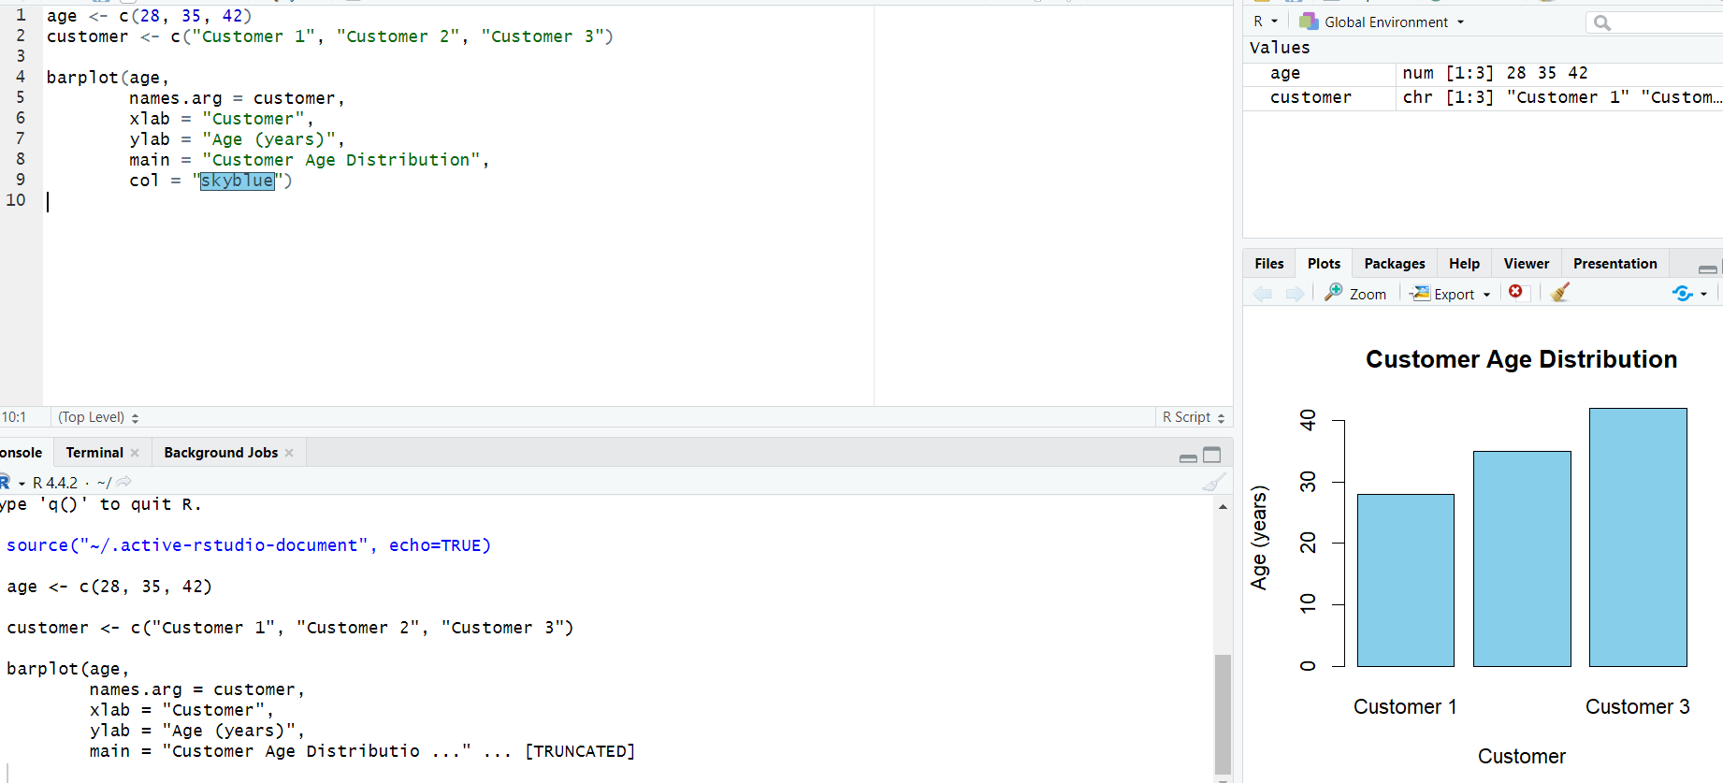

Figure 1: Bar chart showing the age of each customer.
Observation: Customer 3 has the highest age (42 years), while Customer 1 has the lowest age (28 years).

PROGRAM 2: Pie Chart of Customer Gender
Generate a pie chart to represent the distribution of customers by gender.
gender <- c("Female", "Male")
count <- c(2, 1)
pie(count,
labels = gender,
main = "Customer Distribution by Gender",
col = c("lightpink", "lightblue"))
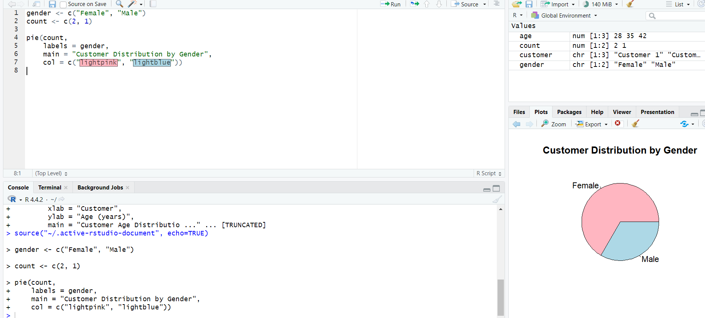
Figure 2: Pie chart showing the gender distribution.
Observation: Female customers account for 2 of the 3 records, while male customers account for 1 record.

PROGRAM 3: Customer Demographic Table
Build a table to display Customer ID, Age, Gender, and Income for each customer.
customer_data <- data.frame(
Customer_ID = c(1, 2, 3),
Age = c(28, 35, 42),
Gender = c("Female", "Male", "Female"),
Income = c(50000, 60000, 75000)
)
customer_data
Customer ID | Age | Gender | Income ($)
1 | 28 | Female | 50000
2 | 35 | Male | 60000
3 | 42 | Female | 75000

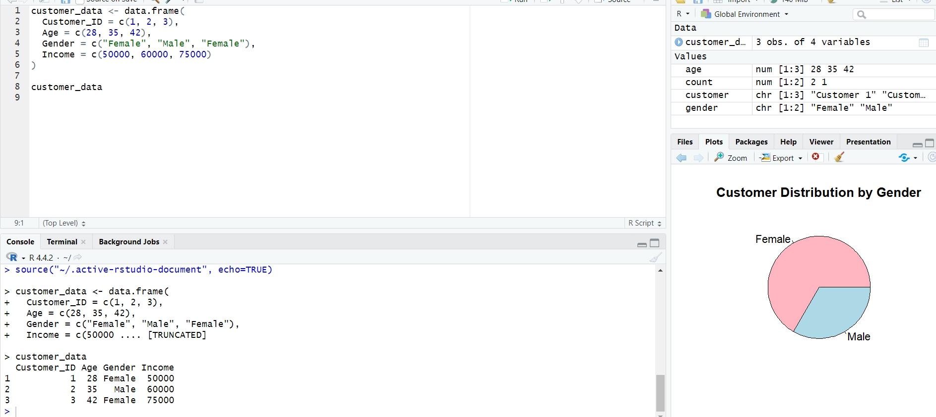Observation: The table provides the complete demographic information for all three customers, making individual records easy to compare.

PROGRAM 4: Tableau Dashboard for Customer Demographics
Develop a Tableau dashboard combining the age bar chart, gender pie chart, and demographic table for interactive exploration.
TABLEAU WORKFLOW
1. Connect Tableau to the Customer Demographics dataset.
2. Worksheet 1 – Age Bar Chart:
• Customer ID → Columns
• Age → Rows
• Enable data labels.
3. Worksheet 2 – Gender Pie Chart:
• Gender → Color
• Customer ID → Angle / Count
• Show percentage labels.
4. Worksheet 3 – Demographic Table:
• Customer ID, Age, Gender, Income → Text.
5. Create a new Dashboard and place all three worksheets on it.
6. Add Gender and Customer ID filters.
7. Add dashboard actions for filtering or highlighting.
8. Add a dashboard title and save the Tableau workbook.
Observation: The dashboard combines age, gender, and individual demographic information so users can inspect the customer records interactively.

Procedure
- Create vectors for customer age, gender, and income from the supplied dataset.
- Use barplot() to visualize customer ages.
- Use pie() to show the gender distribution.
- Create a data frame and display the demographic table.
- Create the age bar chart, gender pie chart, and table in Tableau.
- Combine all three worksheets into a dashboard and add filters or dashboard actions.

Result
The customer demographic data was visualized using a bar chart and pie chart, displayed in a structured table, and combined into a Tableau dashboard for interactive exploration.

Key Functions / Tools Used
Function / Tool | Purpose
barplot() | Creates the customer age bar chart.
pie() | Creates the gender distribution pie chart.
data.frame() | Creates a structured demographic table.
Tableau | Creates interactive worksheets and dashboards.
Filters / Dashboard Actions | Enable interactive demographic exploration.

